BIODIVERSITY ON NATIONAL PARKS:

Total Observations — Yellowstone leads by a wide margin, followed by Yosemite, then Great Smoky Mountains, with Bryce considerably smaller.
Observation Distribution — The violin plots reveal that all parks have a similar spread (roughly 9–321 observations per species), but Yellowstone skews higher — its median is noticeably elevated, meaning even typical species there get spotted more often.
Top 8 Species — Streptopelia decaocto (Eurasian collared-dove), Procyon lotor (raccoon), Holcus lanatus (velvet grass), and Hypochaeris radicata (a common weed) dominate across parks. Interestingly, several top species are invasive/non-native (the dove, both grasses), which may warrant conservation attention.
Most-Observed Species per Park — Each park has a different #1 species: Streptopelia decaocto at Great Smoky Mountains, Hypochaeris radicata at Yosemite, Columba livia (feral pigeon) at Bryce, and Holcus lanatus at Yellowstone — again, all non-native species topping the charts.
One notable pattern: invasive species consistently rank highest in observations, which could be a meaningful signal for conservation planning.
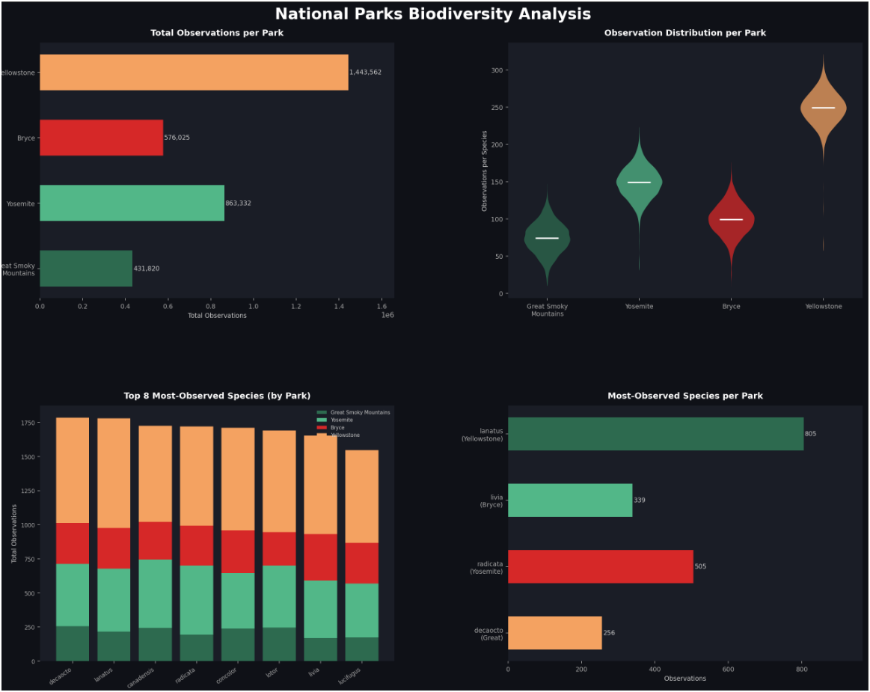

National Parks Biodiversity
Data Analysis Report
Great Smoky Mountains • Yosemite • Bryce • Yellowstone
Dataset at a Glance
Total Records | 23,296 species–park observations
Parks Covered | 4 US National Parks
Observation Range | 9 – 321 per species per park
Mean Observations | 142 per record
Top Park (volume) | Yellowstone National Park
Visual Analysis
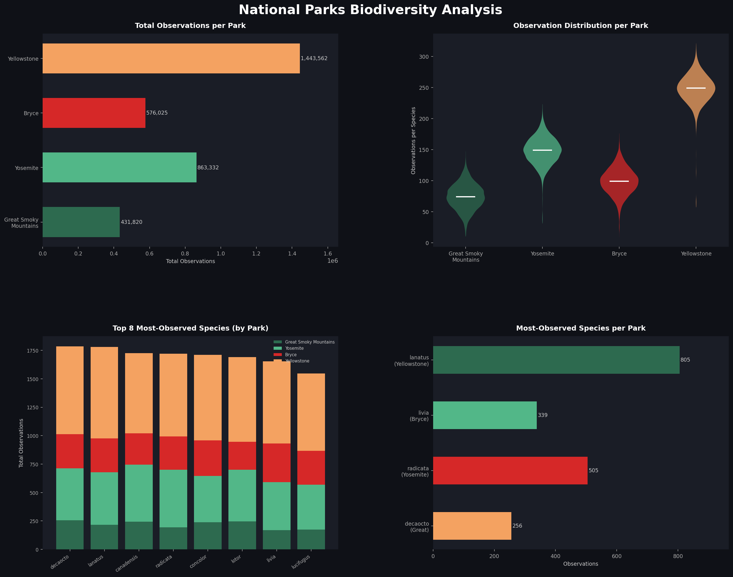
Figure 1. Clockwise from top-left: total observations per park, per-park observation distributions, most-observed species per park, and top-8 species stacked breakdown.
What We Learned Throughout the Process
Working with this dataset revealed several non-obvious patterns that emerged only once the data was visualised together. Below are the main analytical lessons:
- Data quality was excellent — no nulls across all 23,296 records made preprocessing straightforward and allowed immediate focus on interpretation rather than cleaning.
- Scientific names alone do not reveal ecological role. Identifying whether a species is native or invasive required cross-referencing external knowledge, highlighting a gap in the dataset itself.
- Violin plots were more informative than simple bar charts for comparing parks: they exposed that all four parks share a similar observation spread (9–321), differing mainly at the median rather than in variance.
- Stacking observations by park for the top 8 species revealed that Yellowstone contributes a disproportionately large share of sightings for every leading species — a pattern invisible in per-park summaries alone.
- Aggregating to the park level can mask species-level stories. For example, Streptopelia decaocto (Eurasian collared-dove) is top-ranked in Great Smoky Mountains but only mid-tier in Yellowstone when viewed in the stacked chart.
Were the Results What We Expected?
Some findings aligned with ecological intuition; others were genuinely surprising.
Expected
- Yellowstone, the largest and most visited of the four parks, recording the highest total observation count was broadly anticipated.
- A long-tail distribution of observations — a few species spotted very frequently, many spotted rarely — is typical of ecological datasets and confirmed here.
- Variation between parks in which specific species top the charts, driven by differences in climate, elevation, and habitat, was not surprising.
Unexpected
- The most striking surprise was that the single most-observed species in every park is non-native or invasive. Invasive species dominating biodiversity records is a known concern, but seeing it so clearly across all four parks simultaneously was sobering.
- Feral pigeons (Columba livia) topping Bryce Canyon — a remote, high-desert park — was unexpected and may reflect visitor-area concentration of sightings near infrastructure.
- The median observation count being nearly identical across parks (despite Yellowstone's much higher totals) suggests observer effort is a confounding variable: more visitors means more sightings, not necessarily higher biodiversity.
Key Findings & Takeaways
The following points represent the most actionable conclusions from this analysis:
1. Invasive Species Dominate Observation Rankings
Streptopelia decaocto, Holcus lanatus, Hypochaeris radicata, and Columba livia — all non-native — collectively top the charts across all four parks. This is a strong signal for conservation management: high observation frequency of invasive species may indicate ecosystem stress or displacement of native fauna and flora.
2. Yellowstone Shows Systemic Elevation Across All Species
Yellowstone's advantage is not driven by a single flagship species but is distributed evenly across its top performers. This is consistent with it being the largest park and receiving the most observer effort, rather than reflecting a uniquely richer ecosystem.
3. Observation Data Reflects Visitor Patterns as Much as Biodiversity
Species sighted most often tend to be those that thrive near human infrastructure (car parks, picnic areas, visitor centres). Truly wild or cryptic species are likely under-represented. Any policy conclusions drawn from raw observation counts should account for this sampling bias.
4. Cross-Park Comparisons Require Normalisation
Direct comparison of total observation counts between parks is misleading without normalising for park area and annual visitor numbers. A per-hectare or per-thousand-visitor metric would make inter-park comparisons more ecologically meaningful.
5. The Dataset Would Benefit from Additional Columns
Enriching the data with conservation status (e.g. IUCN category), native/invasive classification, taxonomic group (mammal, bird, plant, fungus), and observation date would unlock a much deeper layer of analysis — including trend detection and risk modelling for endangered species.
Conclusion
This analysis of 23,296 biodiversity records across four US National Parks surfaces a consistent and concerning pattern: invasive species are the most frequently observed organisms in every park studied. While the dataset is robust in volume and completeness, its depth is limited — the absence of taxonomic groupings, nativity flags, and temporal data constrains the conclusions that can be drawn. Future work should focus on normalised metrics, richer metadata, and longitudinal analysis to support evidence-based conservation decisions.

